Governor of Bank of England warns of “huge” risks to investors posed by climate change – Carbon Tracker Citations

TOP STORIES

FINANCIAL TIMES
Investors divided over Bank of England chief 's warning on climate change
Financial Times (Main), 01/10/2015, p.3, Pilita Clark
It was agreed at UN climate talks five years ago that temperatures should not rise more than 2C. At around that time, the carbon budget idea was plucked from academia by Carbon Tracker, a London think-tank…
http://www.ft.com/intl/cms/s/0/edc9bae6-678f-11e5-97d0-1456a776a4f5.html#axzz3nHHjOeo8

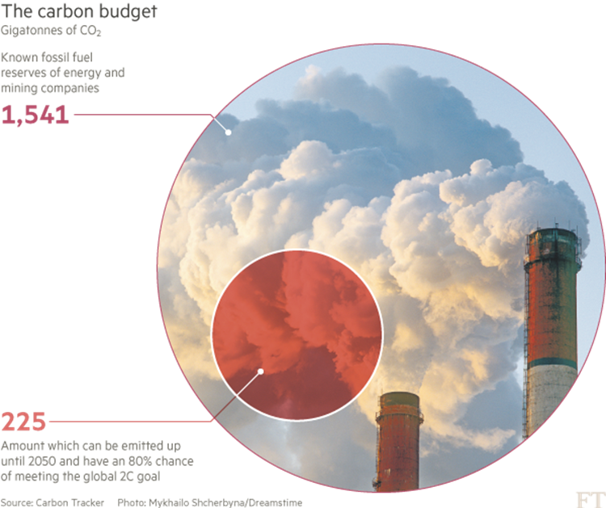

Mark Carney, the former Goldman Sachs banker now running the Bank of England, is either a far-sighted visionary or a dangerously deluded fool.

Such were the wildly contrasting reactions to Mr Carney’s warning that fossil fuel investors face “potentially huge” losses if tougher action on climate change make vast reserves of coal, oil and gas unburnable.

His alert came in a speech to London insurers that has instantly made him the most prominent financial policymaker to endorse the contentious idea that fossil fuel assets could be “stranded” as governments try to curb global warming.

Campaigners say reserves of oil, gas and coal will be abandoned as world moves towards cleaner fuels

The prospect that an idea confined largely to realms of climate science and environmental campaigners was going mainstream drew a strong response from Philip Lambert, founder of Lambert Energy Advisory, a London company involved in several oil and gas deals.

“How on earth can the governor of one of the most responsible institutions in the world think that the thing that produces 85 per cent of the current global energy mix can just suddenly become stranded at a time of rising energy demand and the absence of an affordable alternative?” Mr Lambert said on Tuesday. More…

FINANCIAL TIMES
Carney on climate: Stranded fossil fuel theory proves potent
FT.com (Web), 30/09/2015, Pilita Clark
Of all the recent ideas climate change campaigners have come up with to convince the world to do more to curb global warming, none has been as potent as the concept of stranded fossil fuel assetsAt about that time, the carbon budget idea was plucked from academia by Carbon Tracker, a small London think-tank founded by Mark Campanale, one of the city’s first sustainable investment analysts.
http://www.ft.com/cms/s/0/97ba13d4-6772-11e5-97d0-1456a776a4f5.html#axzz3nCVcjMfo

FINANCIAL TIMES
Mark Carney warns investors face huge climate change losses
FT.Com 30/9/2015, Pilita Clark
The governor of the Bank of England has thrown down the gauntlet to the fossil fuel industry with a blunt warning that investors face “potentially huge” losses from climate change action that could make vast reserves of oil, coal and gas literally unburnable. “A wholesale reassessment of prospects, especially if it were to occur suddenly, could potentially destabilise markets,” he said, echoing warnings from the Carbon Tracker think-tank in London that pioneered the stranded carbon assets idea several years ago. http://www.ft.com/intl/cms/s/0/622de3da-66e6-11e5-97d0-1456a776a4f5.html#axzz3nDahyX2i

UK Central Bank Chief Warns Over Climate Change's 'Potentially Huge' Hit To Investors
International Business Times (Web), 30/09/2015, Owen Davis
as much as one-third of the untapped fossil fuels currently owned by extraction companies could become worthless under a concerted environmental protection regime. The Carbon Tracker Institute estimates that only a small fraction of known oil, gas and coal reserves could be burned if humanity wants to keep climate change in check.
http://www.ibtimes.com/uk-central-bank-chief-warns-over-climate-changes-potentially-huge-hit-investors-2121193

Has Mark Carney just taken the carbon bubble theory into the mainstream?

Business Green, Jessica Shankleman

Bank of England Governor's warning could represent a tipping point for the climate change debate, say campaigners
Jeremey Leggett, the former oil industry advisor turned solar energy entrepreneur and climate campaigner, said Carney's announcement was "momentous".
Meanwhile, Mark Campanale, founder and executive director of the Carbon Tracker Initiative, which has led work on the carbon bubble theory, said it was the first time a major international microprudential regulator had clearly set out how climate risk is a material financial risk.
http://www.businessgreen.com/bg/analysis/2428218/has-mark-carney-just-taken-the-carbon-bubble-theory-into-the-mainstream

Bank of England governor Carney warns of financial risk posed by climate
City AM
His speech was welcomed by Mark Campanale, founder of the Carbon Tracker Initiative think tank. "Investors will sit up and take notice of the potential risks and liabilities these companies face and begin to re-price this material risk," said Campanale.
http://www.cityam.com/225444/bank-england-governor-mark-carney-warns-financial-risk-posed-climate-change

Climate change poses risk to financial stability, says Mark Carney
BT.com
Climate change and increasingly severe weather pose a grave risk to financial systems and long-term prosperity, the governor of the Bank of England has said. Mark Carney said that by the time climate change becomes a defining issue for financial ...
http://home.bt.com/news/uk-news/climate-change-poses-risk-to-financial-stability-says-mark-carney-11364008005377

Climate Change poses risk to financial stability, says Mark Carney
AOL UK
Climate change and increasingly severe weather pose a grave risk to financial systems and long-term prosperity, the governor of the Bank of England has said. Mark Carney said that by the time climate change becomes a defining issue for financial ...
http://www.aol.co.uk/news/2015/09/30/climate-change-poses-risk-to-financial-stability-says-mark-carney/

Jeremy Leggett: “High chance of a tipping point in retreat from fossil fuels soon”
Blue & Green Tomorrow (Web), 30/09/2015, Unattributed
kind. The final print version of the book will be available for sale early next year, all proceeds going to SolarAid . I want to thank the brilliant team at Carbon Tracker , who I have the privilege of chairing. Their work has been of extraordinary influence in what the Guardian calls “the biggest story ever”.
http://blueandgreentomorrow.com/features/jeremy-leggett-high-chance-of-a-tipping-point-in-retreat-from-fossil-fuels-soon/

Bank of England warns of climate change risk to economy
BQ Magazine (Web), 30/09/2015, Unattributed
and reliable carbon disclosure that will allow investors to make a more informed assessment of the climate risks in their portfolios". Mark Campanale, the founder and executive director of the Carbon Tracker Initiative, added: "Carbon Tracker welcomes this important milestone, a major international microprudential regulator clearly setting out for the first time how climate risk is a material financial risk.
http://www.bqlive.co.uk/2015/09/30/financial-risk-of-climate-change-highlighted/

There were an additional 25 to 30 stories in the regional UK press who republished the UK Press Association’s (wire) piece. Examples:

Climate change poses risk to financial stability, says Mark Carney
Basildon Recorder
Climate change and increasingly severe weather pose a grave risk to financial systems and long-term prosperity, the governor of the Bank of England has said. Mark Carney said that by the time climate change becomes a defining issue for financial ...
http://www.basildonrecorder.co.uk/news/national/13792068.Climate_change_poses_risk_to_financial_stability__says_Mark_Carney/

Climate change poses risk to financial stability
Western Telepraph
Climate change and increasingly severe weather pose a grave risk to financial systems and long-term prosperity, the governor of the Bank of England has said. Mark Carney said that by the time climate change becomes a defining issue for financial ...
http://www.westerntelegraph.co.uk/news/national/13792068.Climate_change_poses_risk_to_financial_stability__says_Mark_Carney/

